**CONVENTION 2023**

**GREATER NY/NJ REGION 15**

**APRIL 21-23, 2023**

**QUARTET/CHORUS**

**SUPPLEMENT**

**QUARTET/CHORUS COMPETITION SUPPLEMENT – CONTENTS**

Welcome from your Competition Coordinator…………………………………………………………….2

Schedule of Events………………………………………………………………………………………………………4

Final Quartet Order of Appearance……………………………………………………………………………..5

Quartet Walk-On Schedule (Friday, April 21, 2023 @ESPCC; 9:45 AM start)………………..6

Quartet Competition Pattern for Friday, April 21, 2023……………………………………………….7

Chorus Competition Pattern for Saturday, April 22, 2023…………………………………………….8

Final Chorus Order of Appearance……………………………………………………………………………….9

Chorus Traffic Pattern (Leave Hotel/On-Stage Times)………………………………………………….10

Chorus Friday Night Rehearsal Schedule………………………………………………………………………11

Saturday Morning Chorus Breakfast Rooms…………………………………………………………………12

COVID PROTOCOL………………………………………………………………………………………………………..13

Special Instructions for Open Division Competitors……………………………………………………..13

Rule Infraction Penalties (For All Competitors)…………………………………………………………….14

Staging…………………………………………………………………………………………………………………………14

Contest Reminders/International Rules………………………………………………………………………..15

Traffic Pattern Procedure for Handling Personal Belongings Backstage………………………..15

Competitors Needing Special Assistance……………………………………………………………………….16

Chorus Competition Traffic Pattern Information……………………………………………………………16

International and Regional Awards (Return)………………………………………………………………….17

Distribution of Results……………………………………………………………………………………………………17

Dual Members ………………………………………………………………………………………………………………17

Badge Pickup and Housing Check-in Information…………………………………………………………..18

Photo Procedures/Ordering…………………………………………………………………………………………..19

“Primp” Room /Dressing Room Information………………………………………………………………….19

Thursday Briefing Information and Forms……………………………………………………………………..20

Thursday Night Briefing Information…………………………………………………………………21

(Chorus) List of Competing Members ………………………………………………………………22

Chorus Song & Arranger Form (2 pages)…………………………………………………………..24

Quartet Form & Arranger Song (2 pages)………………………………………………………….26

SAI Photo Waiver Form……………………………………………………………………………………..28

Regional Quartet Open Division Cue Sheet (2 pages)…………………………………………30

ESPCC Floor Plan…………………………………………………………………………………………………………….31

Alternate (Small) Riser Configuration (NO REVERSE)……………………………………………………….32

Standard Riser Configuration (WITH REVERSE)………………………………………………………………..33

# **WELCOME GREETING FROM YOUR COMPETITION COORDINATOR**

Hello Greater NY/NJ Region #15. Almost time for contest! I am sooo excited. Please give me a quick hello when you see me. I will be the redhead backstage with the clipboard telling everyone “No Talking Backstage!!!! We on the RCC (Regional Competition Committee) can hardly believe it! With Regional Competition being just a few short weeks away, the RCC is in the final stages of making preparations for what we hope will be another memorable and rewarding experience for all. This is a group of hard-working and dedicated people - Please stop and thank them for all they do on behalf of you, the members of the fabulous Region 15! In addition to wishing all competitors a fantastic time on stage, I hope you all will have a wonderful weekend greeting old friends and making new ones.

In this Competition Supplement, you will find all the pertinent information to finalize your plans and make your time on stage the best it can be. We have included the Order of Appearance for each contest, contest traffic patterns, Quartet Walk-On Schedule, stage diagrams, forms that need to be turned in at the briefing (and the number of each required), riser configuration specs and a copy of the ESPCC Floor Plan. We hope that by including these here in one place, it will make it easier to comply with all of SAI’s contest requirements. PLEASE REVIEW AND COMPLY IN A TIMELY MANNER WITH THIS YEAR’S COVID RELATED REQUIREMENT, i.e. a self-test 24-48 hours prior to your anticipated arrival in Albany.

As in the past, The Joint Briefing will be held on Thursday Night at 7:30 at the Hilton (Governor Ballroom A and B). All forms, awards that need to be returned, and banners should be brought to the room next door beginning at 6:45, with enough time to get to the briefing at 7:30. **Please arrange to have all of this done no later than 7:15, so the briefing can start promptly.** **Packets of these forms need to be provided to the Judging Panel before we begin the briefing.** Please review again the required number of copies of each form. The RCC will not be in a position to make copies if you fail to bring the required number. The Blue Notes Chorus Guides will meet with me and Barbara Wright (CRC) immediately after the briefing has concluded. As soon as that meeting is concluded, the Blue Notes Chorus will assemble for rehearsal.

Weather permitting, the Mass Sing will be held at West Capitol Park at noon on Friday, April 21st. From there, head on over to the base of The Egg and peruse the boutique, which will be just outside the auditorium where the contest will take place.

Quartet Walk-ons are scheduled to begin at **9:45** on Friday morning, right after the Site Inspection/Audio/Visual Checks. The proposed schedule is included in this supplement. This may have to be adjusted if the Inspection runs over in order to accommodate everyone and still begin the contest at 1:30. **PLEASE ADVISE ASAP IF YOUR QUARTET DOES NOT INTEND TO USE ITS SCHEDULED TIME AND I WILL ADJUST THE SCHEDULE ACCORDINGLY**. There will be buses running every 10 minutes on Friday morning to get the quartets to the ESPCC for their walk-ons.

There are 19 quartets entered, including two in the Open Division and two for evaluation. The entry back into the contest venue will be via the doors closest to the Stage at Stage Right, allowing for time for audience members to cheer/welcome their favorite quartets.  **ONLY COMPETING QUARTET MEMBERS WILL BE ALLOWED ACCESS VIA THESE DOORS, IMMEDIATELY AFTER THEIR PERFORMANCE ON STAGE.** You will be directed from the backstage area to the door closest to the stage to return to the auditorium.

As soon as the quartet contest is concluded, members of the Blue Notes Chorus will be asked to assemble backstage at Stage LEFT. There will be a Roll Call of members of the Blue Notes Chorus (comprised of all members of past Championship Quartets from Region 15 and former Region 16 who are now a wonderful part of Region 15), followed by their performance. Please contact Jean Schoenlank if you believe you should be included and have not heard from her. Immediately following, Illuminate Quartet will perform their swan song set. Quartet award presenters will also be asked to gather backstage at this time. **MEMBERS OF ALL COMPETING QUARTETS WILL ASSEMBLE ON THE RISERS FOR THE ANNOUNCEMENT OF THE WINNERS.** Please come backstage quickly as soon as Illuminate Quartet completes their set.

The Chorus Contest will begin at 12:00 pm on Saturday, April 22nd. There are 14 entrants, including two for evaluation. **CHORUSES PLEASE NOTE: AS A REMINDER, RISER BAGS AND INDIVIDUAL ZIPLOC BAGS WILL NOT BE PROVIDED BY THE RCC. EACH CHORUS WILL BE RESPONSIBLE FOR BRINGING THEIR OWN RISER BAGS AND ZIPLOC BAGS. NO WATER BOTTLES PERMITTED!!!!! PLEASE BE KIND TO THE AC MEMBERS MOVING THESE BAGS AROUND AND KEEP THE CONTENTS TO A MINIMUM**.

Immediately after Greater Nassau competes for evaluation, they will exit the stage and line up on the ramp backstage for their outgoing Champion Performance. While they are lining up, all Directors will be asked to assemble backstage so they can be ready for the Parade of Directors during GNC’s performance. **THIS INCLUDES DIRECTORS OF CHORUSES COMPETING FOR EVALUATION OR BY VIDEO, IF YOU WILL BE PRESENT. PLEASE ADVISE SO WE CAN MAKE SURE YOUR CERTIFICATE IS PREPARED**. After GNC’S performance, all chorus award presenters will be asked to gather in the backstage area.

**PLEASE BE SURE TO PICK UP BANNERS AND RISER CHAIRS IMMEDIATELY AFTER THE CHORUS CONTEST.** Each chorus should designate a specific individual to be responsible for this, as we have previously had issues about what to do with banners that have been left. With the designation of a specific individual to be responsible for this task, we had no leftover banners the last 3 contests! We will ask for this person’s name at the Briefing.

There will be buses running between the hotel and the ESPCC, as well as buses designated for competitors. **There will be a separate bus designated for the Champion Quartet and the (Overall) Chorus Champion.**

Regional Awards will be presented at the end of the Regional Banquet, which we are thrilled to be bringing back for everyone. I am happy to answer any and all questions and look forward to seeing each of you in Albany. My e-mail address is [JeannePV237@msn.com](mailto:JeannePV237@msn.com). Please stop me, introduce yourself and say hello. I am looking forward to another great weekend of friendship, harmony and FUN (and maybe a little exhaustion!!!!)

In Harmony,

S/*Jeanne P. Viscito*/

Jeanne Viscito, Region 15 Competition Coordinator

# **SCHEDULE OF EVENTS**

**APRIL 20 – 23, 2023**

**Thursday April 20, 2023**

4:00 pm Hotel Check-in

5:30 – 7:30 Boxed dinners available (pre-paid) **Pickup at Hilton restaurant**

6:45 pm - 7:15 pm Hand in forms/return awards – Hilton Governor B

7:30 pm Quartet/Chorus Briefing - Hilton Governor A

Blue Notes Chorus Guides meet with B. Wright (CRC) and J. Viscito (CC), immediately after conclusion of briefing

Blue Notes Chorus Hilton Governor A, immediately after Guides meeting

**Friday, April 21, 2023**

8:00 am Dedicated buses for mic testing chorus/quartet ONLY to ESPCC

8:30 am Facilities inspection/Sound check BY INVITATION ONLY at ESPCC

9:30 am Buses for quartets (walk-ons)

9:45 am Quartet walk-ons at ESPCC

11:00 am – 6:00 pm Boutique open

11:00 am – 7:00 pm Spectator buses between Hilton and ESPCC

11:00 am Registration/ticket sales desk opens at ESPCC

Noon Mass Sing – West Capitol Park (if weather permits. No rain venue.)

1:30 pm Quartet Contest

4:00 pm Hotel check-in available

7:00 – 9:00 pm Buffet dinner (pre-paid) at Hilton Hotel

8:00 & 9:00 pm CHORUS REHEARSALS (see schedule for room assignments)

**Saturday, April 22, 2023**

8:00 am – 9:30 Buffet breakfast for choruses (see schedule for room assignments)

11:00 am – 4:00 pm Boutique open

11:00 am - 5:00 pm Spectator buses between Hilton and ESPCC

11:00 am Registration/ticket sales desk opens at ESPCC

12:00 pm Chorus Contest

6:30 Cocktail Hour, Outside Ballroom

7:30 Regional Banquet, Ballroom (please check list of assigned chorus tables)

8:30 SHOW OF CHAMPIONS/REGIONAL AWARDS, Ballroom

**Sunday, April 23, 2023** Have a safe return home, everyone!

**Region #15 Regional Competition April 21-23, 2023**

**Albany, NY**

# **Final Quartet ORDER OF Appearance**

|  |  |  |
| --- | --- | --- |
| **Cont. #** | **Quartet** | **Chapter(s)** |
| **MT** | **VOCE** | **Chapter-at-Large 1 &15, Millennium Magic (#1)** |
| **1** | **Mardi Gras, EVALUATION** | **Liberty Oak, Chapter-at-Large 15, Hickory Tree** |
| **2** | **Extension Chords** | **Heart of New Jersey, Liberty Oak** |
| **3** | **Just 4 (Kicks)** | **Harmony Celebration, Liberty Oak** |
| **4** | **Empire** | **Chapter-at-Large 15, Sirens of Gotham** |
| **5** | **Harmonics** | **Chapter-at-Large 15, Harmony Celebration, Jersey Harmony** |
| **6** | **Naturally One** | **Harmony Celebration, Saratoga Soundtrack** |
| **7** | **Tag Team** | **Greater Nassau** |
| **8** | **Twist of Fate, OPEN DIVISION** | **Chapter-at-Large 14 & 19, Hickory Tree** |
| **9** | **Balancing Act** | **Liberty Oak** |
| **10** | **Mad Caps, OPEN DIVISION** | **Capitaland** |
| **11** | **Amethyst WITHDRAWN** | **Liberty Oak** |
| **12** | **Repeat Offenders** | **Harmony Celebration, Sirens of Gotham** |
| **13** | **Harmony** | **Greater Nassau Chapter** |
| **14** | **After Hours** | **Capitaland** |
| **15** | **Sympatico** | **Greater Nassau, Sirens of Gotham, Twin County** |
| **16** | **Steppin’ Out** | **Hickory Tree** |
| **17** | **Elixir** | **Liberty Oak, Harmony Celebration, Philadelphia Freedom (#19)** |
| **18** | **Illuminate** | **Coastline Show (#1), Merrimack Valley (#1), Saratoga Soundtrack, Spirit of Syracuse** |
| **19** | **Anthology** | **Liberty Oak, Chapter-at-Large 15** |
| **20** | **VOCE, EVALUATION** | **Chapter-at-Large 1 &15, Millennium Magic (#1)** |

QUARTET WALK-ON SCHEDULE – FRIDAY, APRIL 21, 2023 @ESPCC **(REVISED 3/14/23)**

CONTESTANTS: **PLEASE arrive 10 MINUTES before your scheduled time.** **YOU WILL ENTER THE STAGE FROM THE BACKSTAGE AREA AFTER WALKING THE CONTEST PATTERN. PLEASE BEGIN THE PATTERN AT THE ENTRANCE FROM THE ESPCC PLAZA.** If all members are not present at your assigned time, you will go onstage without them or forfeit your time. Quartets will be allowed 3 MINUTES on stage, which is clocked from the moment the first member steps on-stage. The additional minute allowed in the schedule is for on and off between quartets. You will all enter from Stage Left or Center Entry. Please let me know at the briefing which entrance you will use. There may be (and most likely will be) other people in the ESPCC at these times. I cannot give you time alone in the center. If you choose not to do a walk-on, please let me know so I can adjust this schedule. Contest will begin at **1:30** on Friday. Last quartet estimated to be on stage at **5:41** PM, with the Blue Notes Chorus estimated performance time at **6:00**. Quartets will assemble on the risers immediately after the Illuminate Quartet performance (swan song), and receive their awards. Championship Quartet will perform one song. Best of luck to all of you for a wonderful performance. Go out there and show the rest of Region 15 how awesome our quartets are, and what they are missing!

In Harmony, Jeanne Viscito, Region 15 CC

QUARTET WALK-ON TIME

1. Mardi Gras 9:45 17 Elixir 10:45

2 Extension Chords 9:49 18 Illuminate 10:49

3 Just 4 (Kicks) 9:53 19 Anthology 10:53

4 Empire 9:57

1. Harmonics 10:01
2. Naturally One 10:05
3. Tag Team 10:09
4. Twist of Fate (OPEN) 10:13 **NOTE: TIMES ARE SUBJECT TO CHANGE IF**
5. Balancing Act 10:17 **THE OFFICIAL INSPECTION RUNS LATER**
6. Mad Caps (OPEN) 10:21 **THAN EXPECTED.**
7. Amethyst  **WITHDRAWN**
8. Repeat Offenders 10:25 Since VOCE is Mic Testing, I did not give them
9. Harmony 10:29 additional stage time. If they want it, it will
10. After Hours 10:33 be at 10:57
11. Sympatico 10:37
12. Steppin’ Out! 10:41



|  |  |  |  |  |  |  |  |  |
| --- | --- | --- | --- | --- | --- | --- | --- | --- |
| 2023 Region 15  Chorus Competition Schedule for Saturday, April 22, 2023 | | | | | | | | |
|  |  | Pick Up Hotel Lobby Hotel Lobby | | Arrival | Dressing Room | | BackStage | On Stage |
| # | Contestant | Enter | Leave | at ESPCC | Enter | Leave |  |  |
|  | Opening Remarks/Introduction of Emcee | | | | | | 11:50 | 11:55 |
| 1 | City of the Hills (15) EVALUATION | 11:13 | 11:23 | 11:33 | 11:40 | 11:50 | 11:55 | 12:00 |
| 2a | Long Island Sound (29) | 11:24 | 11:34 | 11:44 | 11:51 | 12:01 | 12:06 | 12:11 |
| 2 | Heart of New Jersey (21) | 11:35 | 11:45 | 11:55 | 12:02 | 12:12 | 12:17 | 12:22 |
| 3 | Island Hills (28) | 11:46 | 11:56 | 12:06 | 12:13 | 12:23 | 12:28 | 12:33 |
| 4 | Hickory Tree (30) | 11:57 | 12:07 | 12:17 | 12:24 | 12:34 | 12:39 | 12:44 |
| 5 | Jersey Harmony (20) | 12:08 | 12:18 | 12:28 | 12:35 | 12:45 | 12:50 | 12:55 |
|  | INTERMISSION/RISER CHANGE - 40 MINUTES (30 MINUTES ANNOUNCED) **[1:06 1:50]** | | | | | | | |
| 6 | Evergreen (24) | 1:03 | 1:13 | 1:23 | 1:30 | 1:40 | 1:45 | 1:50 |
| 7 | Spirit of Syracuse (50) | 1:14 | 1:24 | 1:34 | 1:41 | 1:51 | 1:56 | 2:01 |
| 8 | Saratoga Soundtrack (30) | 1:25 | 1:35 | 1:45 | 1:52 | 2:02 | 2:07 | 2:12 |
| 9 | Capitaland (29) | 1:36 | 1:46 | 1:56 | 2:03 | 2:13 | 2:18 | 2:23 |
| 10 | Liberty Oak (77) | 1:47 | 1:57 | 2:07 | 2:14 | 2:24 | 2:29 | 2:34 |
| 11 | Twin County (35) | 1:58 | 2:08 | 2:18 | 2:25 | 2:35 | 2:40 | 2:45 |
| 12 | Harmony Celebration (45) | 2:09 | 2:19 | 2:29 | 2:36 | 2:46 | 2:51 | 2:56 |
| 13 | Greater Nassau (53) EVALUATION | Meeting Room 7 @2:30; Head Backstage @ 2:57 | | | | | 3:02 | 3:07 |
|  | Greater Nassau - Performance/Parade of Directors TIME APPROXIMATE | | | | | | | 3:25 |
|  | Awards Presentation | TIME APPROXIMATE | | | | | | 3:40 |
|  | HOW WE SANG TODAY/END OF EVENT | TIME APPROXIMATE | | | | | | 4:30 |
| NOTE: Contestant #13 is the Host Chapter. Many of the members will already be at the ESPCC doing their assigned jobs. If there are any GNC members at the Hilton, please have them get on the bus with Harmony Celebration Chorus. | | | | | | | | |
|  |

**REGION #15 REGIONAL COMPETITION APRIL 20-23, 2023 ALBANY, N.Y.**

**FINAL CHORUS ORDER OF APPEARANCE**

**OAP# CHAPTER/CHORUS LOCATION DIRECTOR**

**0 Heart of Long Island Holtsville, NY**

***Video Evaluation***

**0 Sirens of Gotham New York, N.Y.**

***Video Evaluation***

***Non-Inverted Risers*:**

**1 City of the Hills Oneonta, N.Y. Theresa Hait**

***Evaluation Only***

**2a Long Island Sound Hampton Bays, N.Y. Peggy Di Sunno**

**2 Heart of New Jersey Millstone Township, N.J. Jeanne Elmuccio**

**3 Island Hills Hauppauge, N.Y. Laura Riffaud**

**4 Hickory Tree Stirling, N.J. Carolyn Schmidt**

**5 Jersey Harmony Princeton, N.J. Kat Britt**

***Inverted Risers*:**

**6 Evergreen Poughkeepsie, N.Y. Carole Argulewicz**

**7 Spirit of Syracuse Syracuse, N.Y. Kay Crawford**

**8 Saratoga Soundtrack Saratoga Springs, N.Y. Jennifer Hunter**

**9 Capitaland Albany, N.Y. Susan Koppenhaver**

**10 Liberty Oak Marlboro, N.J. Katie Blackwood**

**11 Twin County Massapequa, N.Y. Christine Krowles**

**12 Harmony Celebration Ridgewood, N.J.**

**13 Greater Nassau Baldwin, N.Y. Harriette Walters**

***Evaluation Only***

|  |  |  |  |  |
| --- | --- | --- | --- | --- |
| REGION 15 CHORUS COMPETITION 2023 Traffic Pattern Schedule | | | | |
| # | Chorus | Hotel | Departure | Stage |
| 1 | City of the Hills (15) EVALUATION | Hilton | 11:23 | 12:00 |
| 2a | Long Island Sound (29) | Hilton | 11:34 | 12:11 |
| 2 | Heart of New Jersey (21) | Hilton | 11:45 | 12:22 |
| 3 | Island Hills (28) | Hilton | 11:56 | 12:33 |
| 4 | Hickory Tree (30) | Hilton | 12:07 | 12:44 |
| 5 | Jersey Harmony (20) | Hilton | 12:18 | 12:55 |
| INTERMISSION/RISER CHANGE | | | | |
| 6 | Evergreen (24) | Hilton | 1:13 | 1:50 |
| 7 | Spirit of Syracuse (50) | Hilton | 1:24 | 2:01 |
| 8 | Saratoga Soundtrack (30) | Hilton | 1:35 | 2:12 |
| 9 | Capitaland (29) | Hilton | 1:46 | 2:23 |
| 10 | Liberty Oak (77) | Hilton | 1:57 | 2:34 |
| 11 | Twin County (35) | Hilton | 2:08 | 2:45 |
| 12 | Harmony Celebration (45) | Hilton | 2:19 | 2:56 |
| 13 | Greater Nassau (53) EVALUATION | Hilton/ESPCC | *** | 3:07 |
| NOTE: Contestant #13 is the Host Chapter. Many of the members will already be at the ESPCC doing their assigned jobs. If there are any GNC members at the Hilton, please have them get on the bus with Harmony Celebration Chorus. | | | | |

**REGION 15 REGIONAL COMPETITION 2023**

**FRIDAY NIGHT CHORUS REHEARSALS**

|  |  |  |
| --- | --- | --- |
| ROOM | 8:00 – 9:00 PM | 9:00 – 10:00 PM |
|  |  |  |
| GOVERNOR A (56) | City of the Hills (15) | Twin County (35) |
|  |  |  |
| GOVERNOR B (56) | Long Island Sound (29) | Spirit of Syracuse (50) |
|  |  |  |
| GOVERNOR C (56) | Heart of New Jersey (21) | Saratoga Soundtrack (30) |
|  |  |  |
| GOVERNOR D (56) | Island Hills (28) | Capitaland (29) |
|  |  |  |
| GOVERNOR E (56) | Hickory Tree (30) | Greater Nassau (53) |
|  |  |  |
| HUDSON BALLROOM (40 | Jersey Harmony (20) | Harmony Celebration (45 |
|  |  |  |
| OLD KELSEY (76) | Evergreen (24) | Liberty Oak (77) |

**SATURDAY MORNING CHORUS BREAKFASTS**

**FOOD SERVICE 8:00 – 9:30 AM**

Breakfast buffet will be served beginning at 9:00 am. Separate chorus rooms will be assigned for breakfast; the assigned breakfast room will remain available to the assigned chorus through noon for rehearsals, etc. Choruses who do not elect to participate in the breakfast buffet will be assigned a specific rehearsal room per their request.

|  |  |  |
| --- | --- | --- |
| CONTESTANT #/CHORUS | ROOM | Capacity |
|  |  |  |
| #1 City of the Hills (15) | Empire A | 20 |
|  |  |  |
| #2a Long Island Sound (29) | Capital AB | 36 |
|  |  |  |
| #2 Heart of New Jersey (21) | State A | 20 |
|  |  |  |
| #3 Island Hills (28) | Chambers | 44 |
|  |  |  |
| #4 Hickory Tree (30) | Governor D | 56 |
|  |  |  |
| #5 Jersey Harmony (20) | Empire B | 20 |
|  |  |  |
| #6 Evergreen (24) | State B | 20 |
|  |  |  |
| #7 Spirit of Syracuse (50) | Governor B | 56 |
|  |  |  |
| #8 Saratoga Soundtrack (29) | Governor E | 56 |
|  |  |  |
| #9 Capitaland (29) | ANTEROOM (Breakfast Only) | 36 |
|  |  |  |
| #10 Liberty Oak (77) | Old Kelsey | 76 |
|  |  |  |
| #11 Twin County (35) | Governor A | 56 |
|  |  |  |
| #12 Harmony Celebration (45) | Hudson Ballroom | 40 |
|  |  |  |
| #13 Greater Nassau (53) | Governor C | 56 |

# **COVID PROTOCOL**

# **REQUIRED FOR CHORUS, QUARTET, AND CHAPTER AT LARGE QUARTET MEMBERS (competing but not covered by a competing chorus)**

# **\*Each chorus CCL or Chapter at Large Member will need to email a confirmation that you have received or taken a negative rapid test (home test) for every competing member 24 to 48 hours prior to arrival in Albany.**

# **\*Each chorus CCL or Chapter at Large member will email to Gretchen Danby (**[**gretchen.danby@gmail.com**](mailto:gretchen.danby@gmail.com)**) – Be sure to include your chorus name or that you are Chapter-At-Large in the message. You only need to confirm (as CCL) that you have seen negative rapid test results for all attendees. You DO NOT need to send photos of test results. You can email or text Gretchen at 516-281-5142 if you have any questions.**

# **\*Masks are recommended but optional.**

# **SPECIAL INSTRUCTIONS FOR OPEN DIVISION COMPETITORS**

All Open Division competitors (Quartet and Chorus) must submit a prepared program (10 copies) at the briefing Thursday night. The prepared program must list all planned activity occurring on stage after completion of the entrance and following the official introduction. Planned activity occurring prior to the first word spoken or the first chord of the first song, whichever begins the performance, will result in disqualification if in the opinion of the panel chair and a majority of judges on the panel the time spent is excessive and results in a delay of the contest.

Total Time of the Entertainment Package Session in the Open Division of any official Sweet Adelines competition is:

Quartet: Not more than ten (10) minutes.

Chorus: Not more than ten (10) minutes.

Timing begins at the first word spoken or the first chord of the first song, whichever begins the performance, and continues through the final chord of the last song or the last word spoken, whichever concludes the performance. The three {3) to seven (7) minute timing requirement for the contest song is suspended.

Spoken materials and/or sound effects may be utilized in any of the non-competition songs included in the entertainment package

# **RULE INFRACTION PENALTIES (FOR ALL COMPETITORS)**

The official language for songs designated as competition songs is American English. Languages other than English may be used for noncompetition songs included in the entertainment package.

The official song of Sweet Adelines is ‘How We Sang Today’. This song may not be sung in any competition session, including the entertainment package. Performance of any official song in Open Division will result in disqualification.

Religious and Patriotic songs may not be sung in competition. Performance of a religious or patriotic song as the contest song in Open Division will result in disqualification.

Crowns or tiaras are neither worn by nor presented to any contestant other than the quartet winning first place in the international quartet competition. In all sessions, penalty for violation is twenty-five (25) points. Crowns worn by a contestant in Open Division will result in disqualification.

Only the director(s) and performing members of a competing chorus may appear on stage. A penalty may result if, in the opinion of the official panel, the presence of a "non-singing" member is a distraction and detracts from the musical performance. In all sessions, the penalty ranges from ten (10) to twenty-five (25) points, depending on severity. In Open Division, this may result in disqualification.

# **STAGING**

All props and visual devices must enter and leave the performance venue with the chorus or quartet. Storage space for props or equipment, other than riser chairs or medically necessary items, is not provided at the contest venue.

Props or visual devices requiring excessive set up time will be subject to delay of contest penalties.

All contestants are required to leave the stage in the condition they found it. Anything discarded or dropped must be removed and exit the stage with the contestant. ln all sessions, penalty for violations is twenty-five {25) points.

Any contestant that purposefully throws an object (s) into the audience or judging pit from the competition stage may be assessed a minimum penalty of twenty-five (25) points up to a maximum penalty of disqualification from the contest.

Entertainment Package Sessions: Special staging and/or lighting effects may not be incorporated into the songs designated as competition songs but may, at the discretion of the International Board of Directors, be utilized as part of the noncompetition songs included in the entertainment package.

# **CONTEST REMINDERS / INTERNATIONAL RULES**

**Withdrawals**: Chorus directors, Presidents/TCs, and quartets must withdraw in writing (email is okay) to International Headquarters. A phone call is not sufficient.

**Props rule**: If any object is thrown into the audience or into the judging pit a penalty of 25 points up to the maximum of disqualification from the competition will be enforced.

**Copyright Clearance**: All music must have cleared the copyright process. Failure to use cleared arrangements may result in disqualification. International Headquarters is responsible for administering the copyright policies and procedures.

**Chorus photos** will be taken on stage at the end of the performance.

**Contest score sheet packets** will be distributed in Meeting Room #7, adjacent from the hall.

A curtain will not be used for the contests, and the stage is not carpeted.

**Backstage** entry is for the competitors and coaches only! Please observe the “authorized entry only” signs.

Coaches who accompany a contestant backstage may watch the performance from Stage Left or from the audience. The coach may then join the contestant following the performance.

**There is no VIP Seating**.

# **TRAFFIC PATTERN - Procedure for Handling of Personal Belongings Backstage**

Prior to competition weekend, distribute a “Ziploc” bag to each member with her name clearly printed on a color coded/numbered label. Gallon size bags are adequate. Chorus members are to use this for any personal items taken to the competition facility. **NOTE: PLACE ONLY EMPTY WATER BOTTLES IN ZIPLOC BAGS.**

Individual Ziploc bags are to be placed inside cloth, canvas or paper bags provided by each chorus for each row of the chorus. Bags should be clearly marked with chorus name and row number. Larger choruses may need additional bags per row. **(BAGS WILL NOT BE PROVIDED BY RCC).** Riser bags will be collected upon leaving the primp room, and brought up the ramp backstage where AC members will collect them. Please place masks in your individual Ziploc bags as you leave the primp room. **NOTE: Water and limited final prep supplies will be provided in the Primp room.**

Riser bags will be supervised until collected by the chorus following its on-stage performance. Bags will be retrieved outside the doors where we exit the stage after our performance.

**Competitors Needing Special Assistance:**

Chorus with competitors needing special assistance are to notify Jeanne Viscito, CC, prior to Convention weekend. (Call 908-625-7183 or email [JeannePV237@msn.com](mailto:JeannePV237@msn.com)).

Choruses are expected to provide any extra transportation or assistance (with wheelchairs and scooters) if required. The chorus assistant to the person using these must take the device *behind the open stage and leave it at the stage left exit from the stage before she gets on the* risers.

Chorus personnel will set riser chair(s) on the risers immediately preceding its performance and remove the riser chair(s) immediately following the performance.

All riser chairs are to be delivered to the backstage area between 10:30 am and 11:30 am on Friday, April 21, 2023 and placed along the back wall. Please make sure your riser chairs are CLEARLY marked with your chorus name.

All riser chairs must be removed from the auditorium immediately following the chorus contest session.

Choruses opting to use props in their performance cannot leave any of them backstage or on stage before or after their performance. You carry everything on and everything off – even something you dropped on stage. There is a 25-point penalty assessed by the Showmanship Judge in terms of the degree that the performance is enhanced or detracted from by the use of said props.

# **Chorus Competition Traffic Pattern Information:**

Quartet/Chorus gathers in the hotel lobby no more than 10 minutes before your assigned time and follows directions of the Assisting Chorus member waiting in the lobby. You will NOT be called unless there is a significant change to the schedule.

Quartet/Chorus loads onto buses at a designated departure point in each hotel. Buses will depart promptly on-time and will not wait for singers who may be late.

Chorus arrives at the ESPCC entrance and will be greeted by a Convention Assistant.

Quartet/Chorus escorted to the Dressing/Primp Room. SINGING WIL BE ALLOWED

Quartet/Chorus shown to backstage area and proceeds directly to the stage.

Tote bags will be collected at the top of the ramp after leaving Dressing/Primp Room on the way to the stage.

Please note:

* + Chorus sets up necessary riser chairs at this time.
  + Singers who use wheelchairs must have a chorus member take it to stage left once she is on stage. Back stage staff do not know how to operate them and are busy with their duties.
  + Director to signal regional personnel stage left when ready to begin.
  + Curtain is not utilized.
  + The stage floor will be marked with tape indicating a center-line.
  + Recording microphones will be placed overhead of the risers.
  + Refer to diagram for riser configurations.
  + Chorus removes riser chairs immediately following performance.
  + Chorus MUST remove riser chairs from the ESPCC immediately following the close of the competition awards ceremony.
  + Chorus exits Stage Right. Bags will be retrieved **“outside the double doors where the choruses exit after their performance.”**

**INTERNATIONAL AND REGIONAL AWARDS**

Previous year’s recipients must return all trophies and plaques to Susan Johns-Greenfield, Awards Chair, at the Chorus and Quartet Briefing Thursday, April 20, 2023 at 6:45 pm. (Governor B)

# **DISTRIBUTION OF RESULTS**

Contestant packets containing score sheets and instructions for retrieving copies of your performance DVD will be available approximately 15 minutes following the conclusion of contests. Only the Chorus Director or President/TC may pick up the score sheet packet. Score sheet packets will be distributed in Meeting Room #7, adjacent to the hall.

# **DUAL MEMBERS**

Members with dual membership may compete with each chorus of which she is a member in good standing. The second costume must be brought to the ESPCC **on Saturday, not before** and placed backstage in a designated area (Stage Right) Dual members may use this area to change into their second costume.

**ATTENTION CCL’s –**

# **Badge Pick Up and IMPORANT Housing Check-In Information**

**BADGES & PROGRAMS** for all members, will be available at the Registration Desk, located in the ESPCC boutique area, starting at 11:00 am on Friday morning.

**HOUSING PROCEDURE:** Check in at the Hilton Hotel will be done individually at the Front Desk. CCL’s and/or Housing Chairs should be accessible to their members by cell phone if questions arise.

**Check-in time** **at the Hilton Hotel is 4:00 p.m**. Every effort will be made to have rooms readied early, but how early will depend on how full the hotel is the previous night! Should you arrive before your room is ready, designated secure areas for luggage are available at the hotel. Please remember to be patient and courteous to the Front Desk personnel and the Housekeepers. They will be working as hard as they can to get everyone into their rooms as quickly as possible.

Additional Information:

**Hilton**: Their new system allows for incidentals to be separate from the room charges. Only room charges will appear on the chorus statement. If you want to charge anything to your room, you MUST leave your personal credit card with the front desk upon check-in. You will not be allowed to charge to your room or order room service unless your card is on file.

**Sunday Check-out:**

**New York Choruses**: The CCL will reconcile chorus hotel room charges on-site with the Front Desk and pay any balance due with a chorus check or credit card.

**New Jersey Choruses**: The CCL will reconcile chorus hotel room charges on-site with the Front Desk, resolve any discrepancies and then meet with Phyllis Capolongo in the Lobby to approve Regional payment. If there is any remaining balance, be prepared to give Phyllis Capolongo a chorus check for the balance.

If you require on-site assistance concerning housing arrangements, Johanna Herudek, Regional Housing Manager, can be reached by cell phone. 732-598-5142.

# **Photo Procedures**

QUARTET PHOTOS: Quartet photos will be taken on contest day by a professional photographer – Lindsey Fish – at the Hilton Hotel, in the Old Kelsey Room (immediately behind the lobby registration desk.) Quartets will enter the photo room at their pre-determined time as indicated on the Quartet Competition Schedule.

There is NO UPFRONT CHARGE for the photo session, no payment shall be made to the photographer on-site. During the week immediately following the contest the photographer will post contest photos to her private on-line website, where individuals will be able to order and pay for photos directly from the photographer.

THERE WILL BE A BACKDROP AREA PROVIDED OUTSIDE MEETING ROOM 7 IMMEDIATELY AFTER THE QUARTET CONTEST FOR THE TOP 5 QUARTETS. HAVE YOUR FRIENDS MEET YOU THERE TO TAKE PICTURES WITH YOUR MEDALS!!!!

CHORUS PHOTOS: Chorus photos will be taken while on-stage at the ESPCC by professional photographer Lindsey Fish. She will also be taking candid shots during the competition.

There is NO UPFRONT CHARGE for this photo session, no payment shall be made to the photographer on-site. During the week immediately following the contest the photographer will post contest photos to her private on-line website, where individuals will be able to order and pay for photos directly from the photographer.

Ordering and web-site information will be available and shared during contest weekend.

# **“Primp Room”/DRESSING ROOM**

Quartets and choruses will be directed through the “dressing/primp room,” AND SINGING WILL BE ALLOWED. Additionally, there will be limited supplies and water available.

# **THURSDAY BRIEFING INFO** **AND FORMS**



## THURSDAY NIGHT BRIEFING INFORMATION:

The combined Quartet/Chorus Briefing will be held at 7:30 pm on Thursday, April 20, 2023 in the Hilton Hotel (Governor A). All competing Chorus Directors and Quartets, or their representatives are required to attend this briefing. Presidents/TC’s and CCL’s are welcome and encouraged to attend.

You will be required to bring the following forms to the briefing – Governor B, starting at **6:45 pm**. **ALL FORMS (INCL CORRECT NUMBER OF COPIES) MUST BE TURNED IN PRIOR TO 7:15 PM.**

***Bring chorus banners, plaques, and trophies to Governor B, starting at 6:45 pm.

**CHORUSES**

THREE (3) Copies of the List of Competing Members and Verification Form (single-sided)

ONE (1) Copy of the SAI Photo Waiver for each competing member

**NOTE: IF THE CHORUS IS SINGING DIFFERENT SONGS THAN THOSE INCLUDED ON THEIR REGISTRATION WITH SAI, PLEASE PROVIDE AN AMENDED CHORUS SONG AND ARRANGER FORM (3 copies)**

**QUARTETS**

THREE (3) Copies of the QUARTET SONG AND ARRANGER FORM

ONE (1) Copy of the SAI PHOTO WAIVER for any quartet member who is NOT a member of a

Competing chorus

TEN (10) Copies of 2023 Regional Quartet Open Division Cue Sheet (ONLY IF COMPETING IN OPEN DIVISION – TWIST OF FATE and MAD CAPS QUARTETS)

## List of Competing Members

Please complete and bring THREE (3) COPIES to Thursday Briefing

INSTRUCTIONS:

Fill out the list below in ALPHABETICAL ORDER with members' information and signatures, or attach a list in ALPHABETICAL ORDER with the name, Sweet Adelines International I.D. number and signature of each performer including director(s) who will be appearing on stage. Should a performer not be able to compete after this form is completed, draw a heavy line through the entire line, and correct the TOTAL number listed below. Two copies of this form and the list of competing members (only if it is a separate document) is to be submitted to the COMPETITION COORDINATOR during the chorus directors’ briefing at the regional competition. **Please DO NOT mail to international headquarters**.

Date of Competition:________________ Region:__________ Contestant Number:_________

Chapter Name:_______________________________________________________________________________

Director(s):__________________________________________________________________________________

As officers of said chorus we certify that all participants in the Regional Chorus Competition in Region # _____ are in good standing in the chapter and the chapter is current in the payment of Per Capita Fees (processed at international headquarters).

NOTE: Regional competitions are considered to be the culmination of the region's fiscal year. When competitions are held after April 30 (the end of the fiscal year), "good standing" shall be interpreted as pertaining to the payment of Per Capita Fees for the fiscal year represented by the competitions, i.e., the year that just ended.

Should a complaint regarding ineligibility of any participant be registered with international headquarters within 30 days following the competition, and should that complaint be verified, we understand that our chorus will be disqualified and any rank earned will revert to the next highest scoring chorus.

Signed by:

Chapter President____________________________________________________________________________

Chapter Director_____________________________________________________________________________

The number listed below is used in determining eligibility for the Division A Small Chorus Awards (15 - 30) and the Division AA Mid-size chorus awards (31-60). Eligibility is determined by the number of singing members on stage.

TOTAL number of singing members on stage (director not included in count): __________________

**By signing below, I agree to all competition rules as stated on the registration form and signed by the President and Director.**

|  |
| --- |
| CHORUS NAME: |

|  | ID Number | Member Name | Member Signature |
| --- | --- | --- | --- |
| 1 |  |  |  |
| 2 |  |  |  |
| 3 |  |  |  |
| 4 |  |  |  |
| 5 |  |  |  |
| 6 |  |  |  |
| 7 |  |  |  |
| 8 |  |  |  |
| 9 |  |  |  |
| 10 |  |  |  |
| 11 |  |  |  |
| 12 |  |  |  |
| 13 |  |  |  |
| 14 |  |  |  |
| 15 |  |  |  |
| 16 |  |  |  |
| 17 |  |  |  |
| 18 |  |  |  |
| 19 |  |  |  |
| 20 |  |  |  |
| 21 |  |  |  |
| 22 |  |  |  |
| 23 |  |  |  |
| 24 |  |  |  |
| 25 |  |  |  |
| 26 |  |  |  |
| 27 |  |  |  |
| 28 |  |  |  |
| 29 |  |  |  |
| 30 |  |  |  |
| 31 |  |  |  |
| 32 |  |  |  |
| 33 |  |  |  |
| 34 |  |  |  |
| 35 |  |  |  |
| 36 |  |  |  |
| 37 |  |  |  |
| 38 |  |  |  |
| 39 |  |  |  |
| 40 |  |  |  |
| 41 |  |  |  |
| 42 |  |  |  |
| 43 |  |  |  |
| 44 |  |  |  |
| 45 |  |  |  |
| 46 |  |  |  |
| 47 |  |  |  |
| 48 |  |  |  |
| 49 |  |  |  |
| 50 |  |  |  |
| 51 |  |  |  |
| 52 |  |  |  |
| 53 |  |  |  |
| 54 |  |  |  |
| 55 |  |  |  |
| 56 |  |  |  |
| 57 |  |  |  |
| 58 |  |  |  |
| 59 |  |  |  |
| 60 |  |  |  |
| 61 |  |  |  |
| 62 |  |  |  |

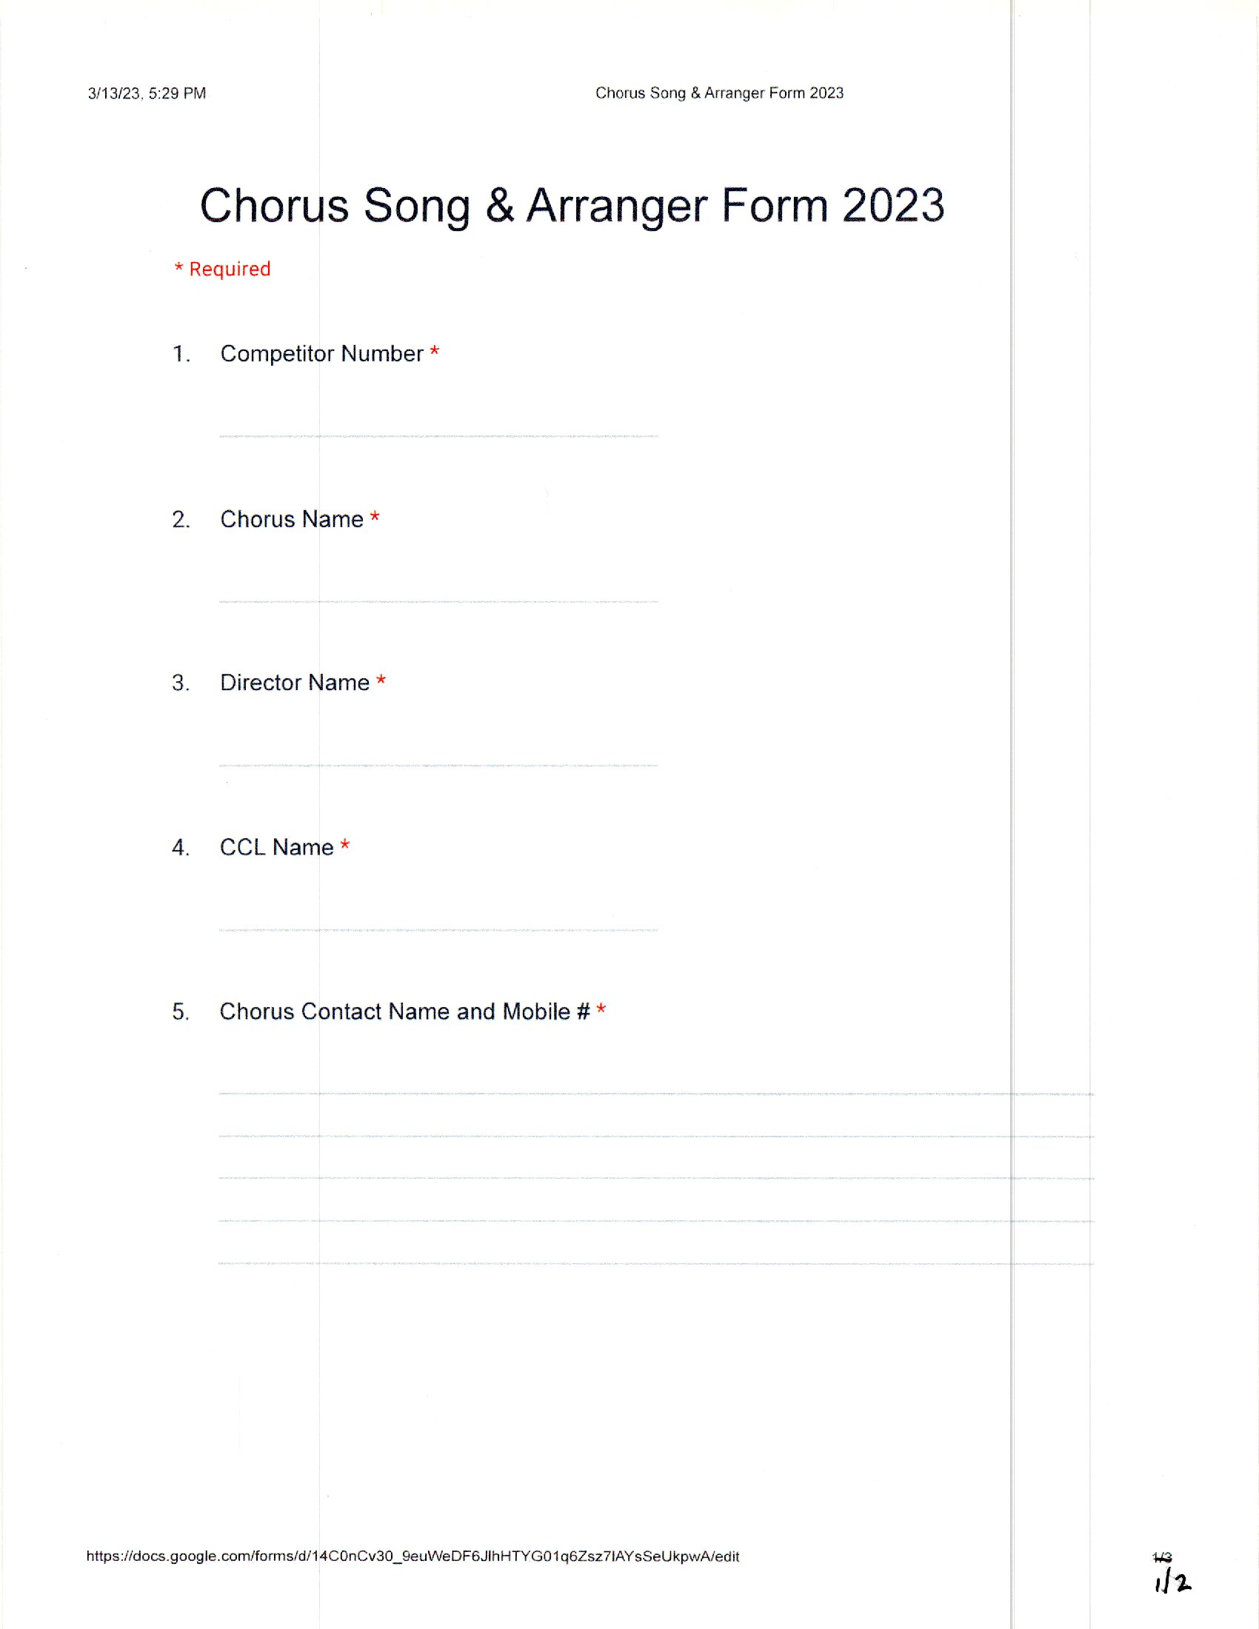

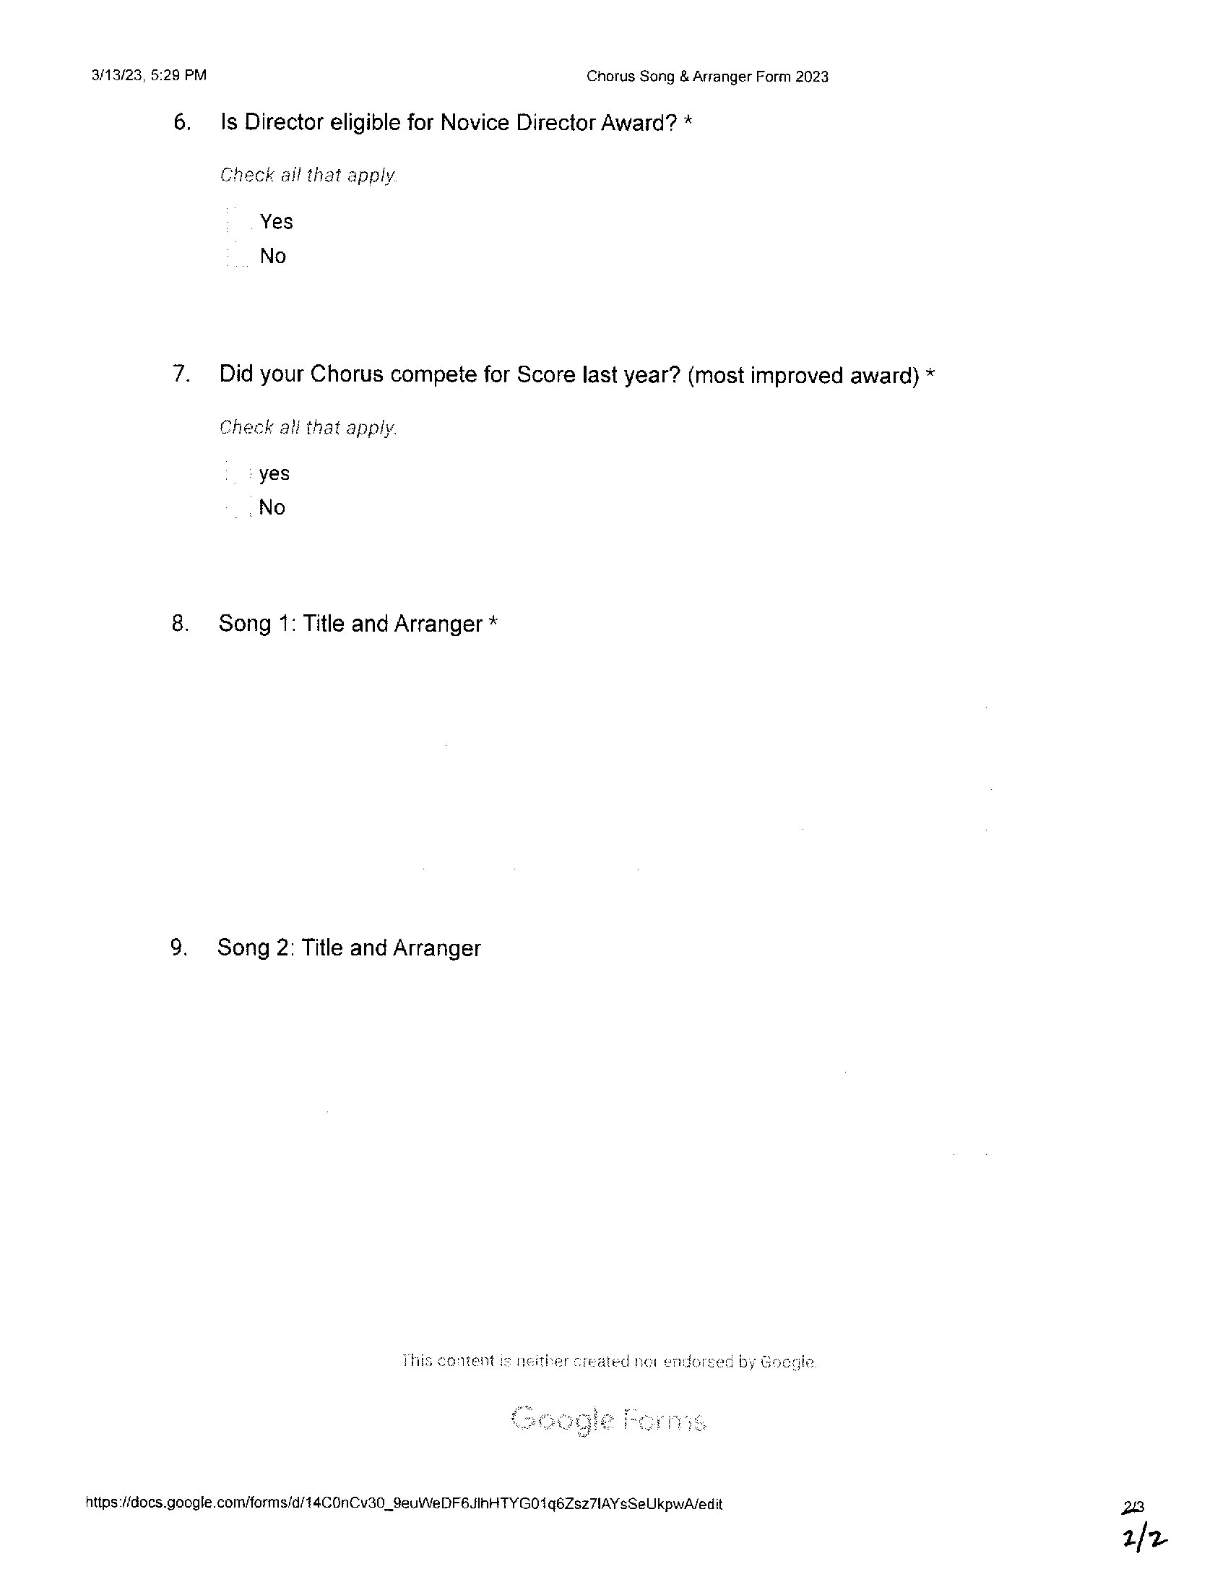

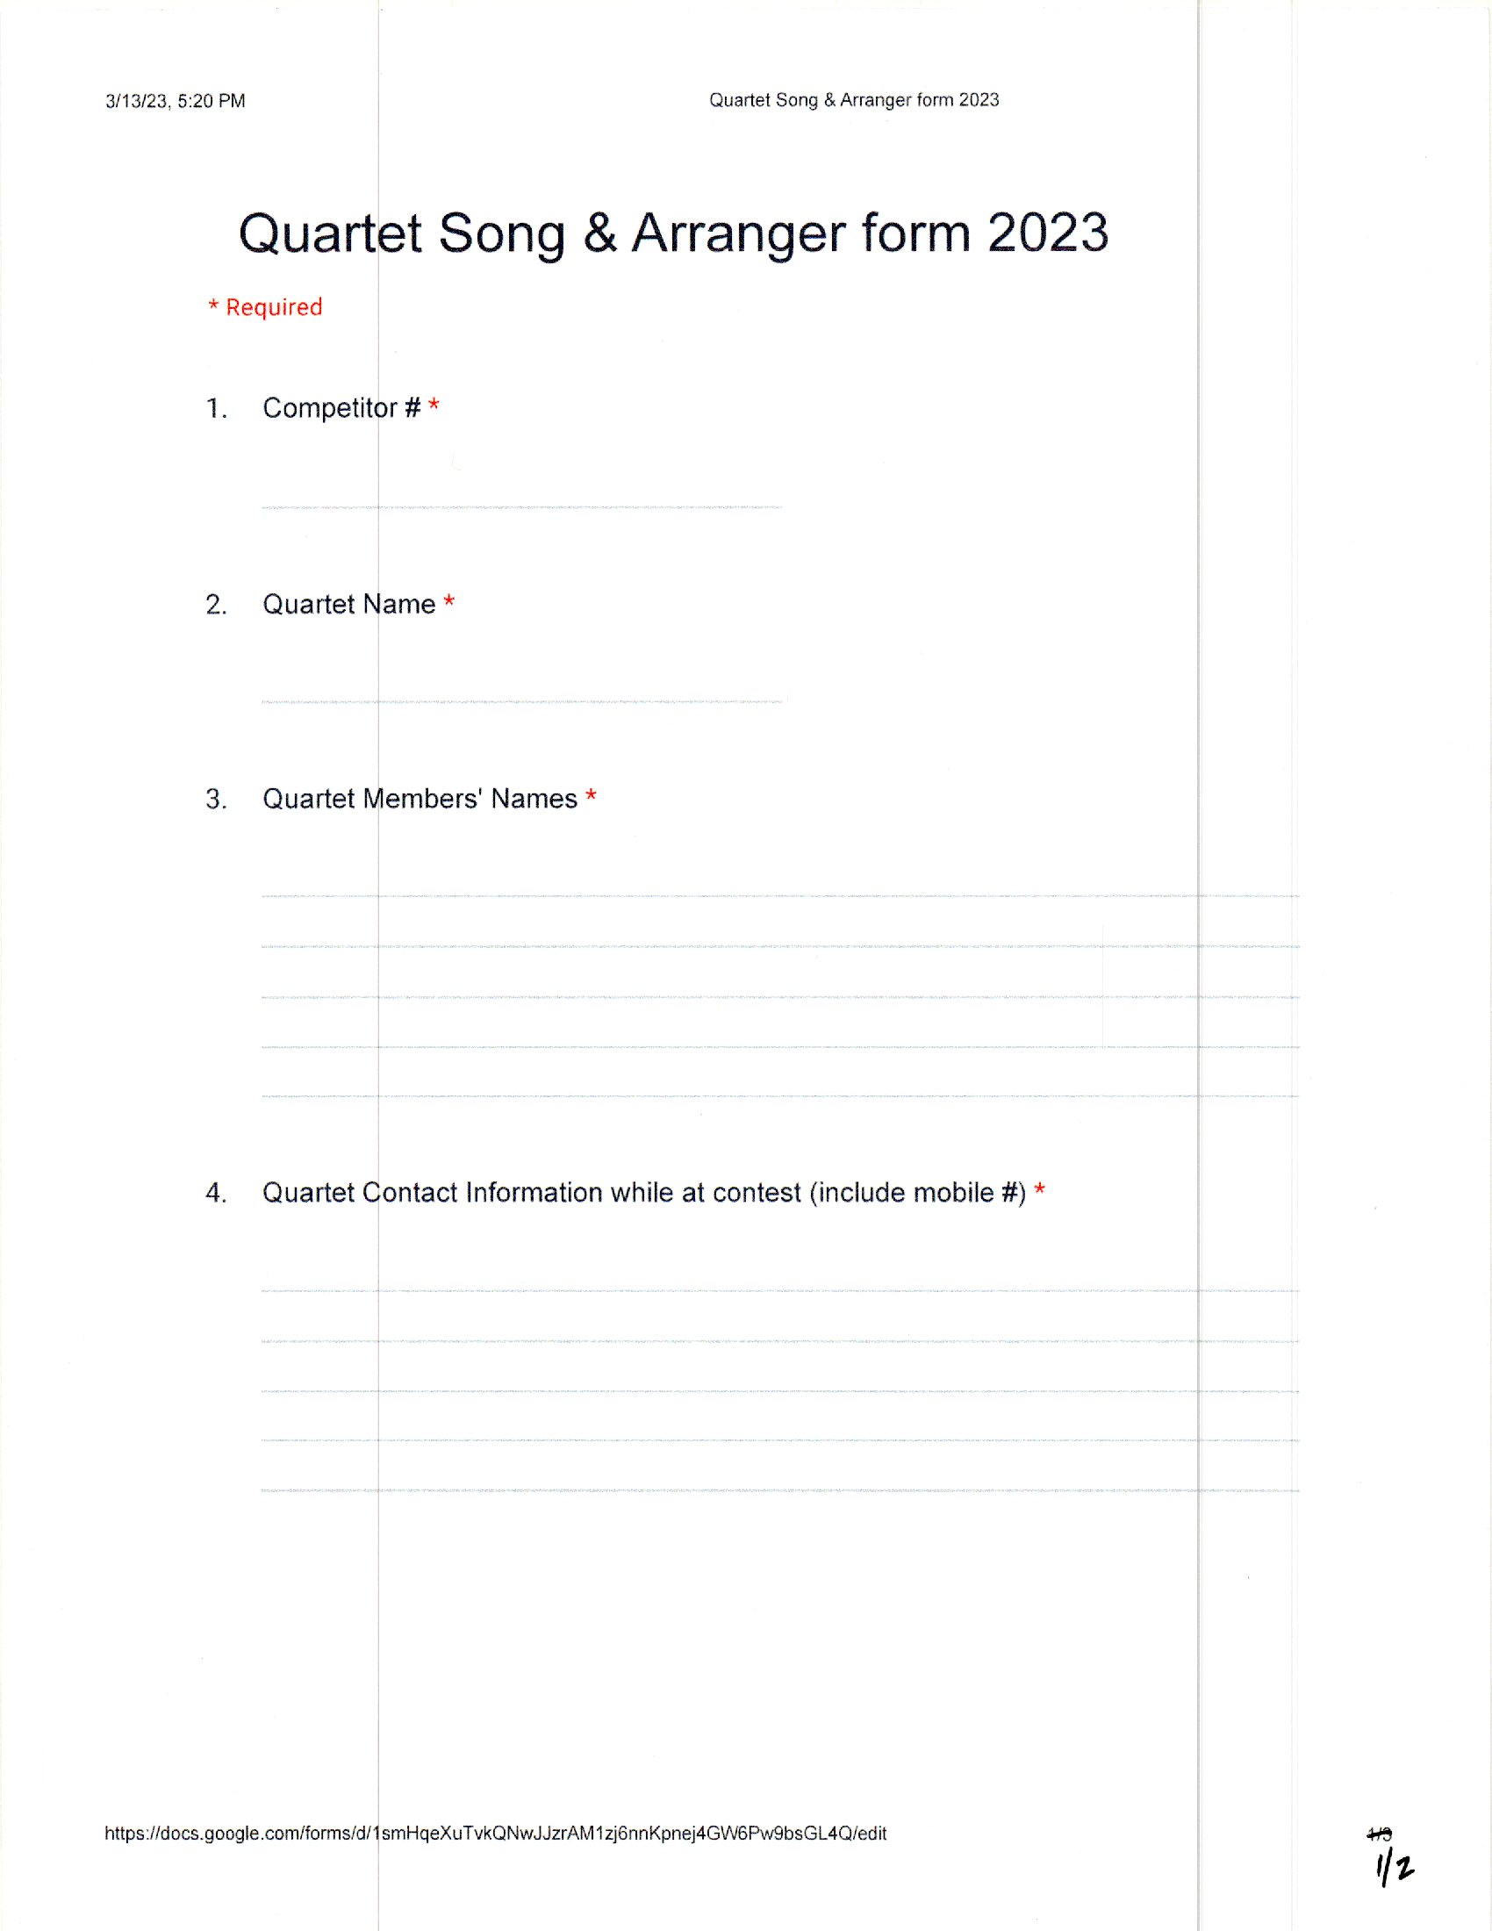

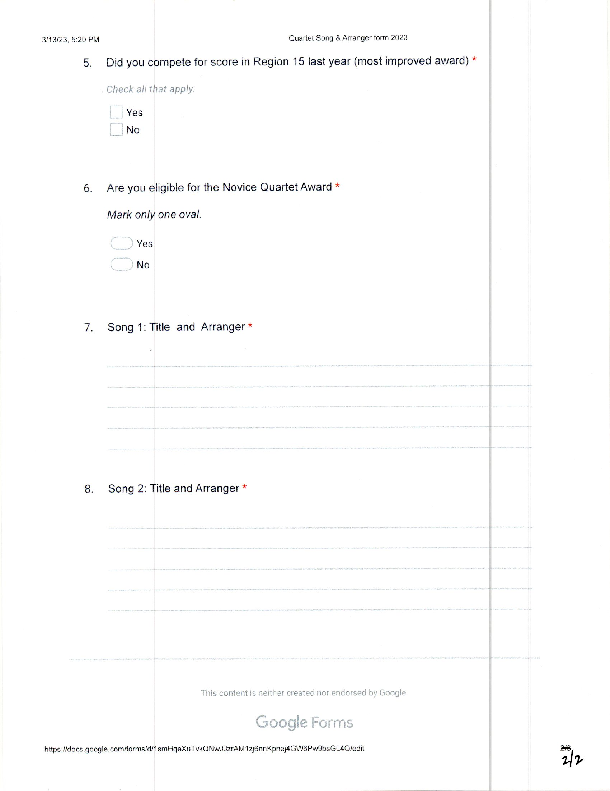

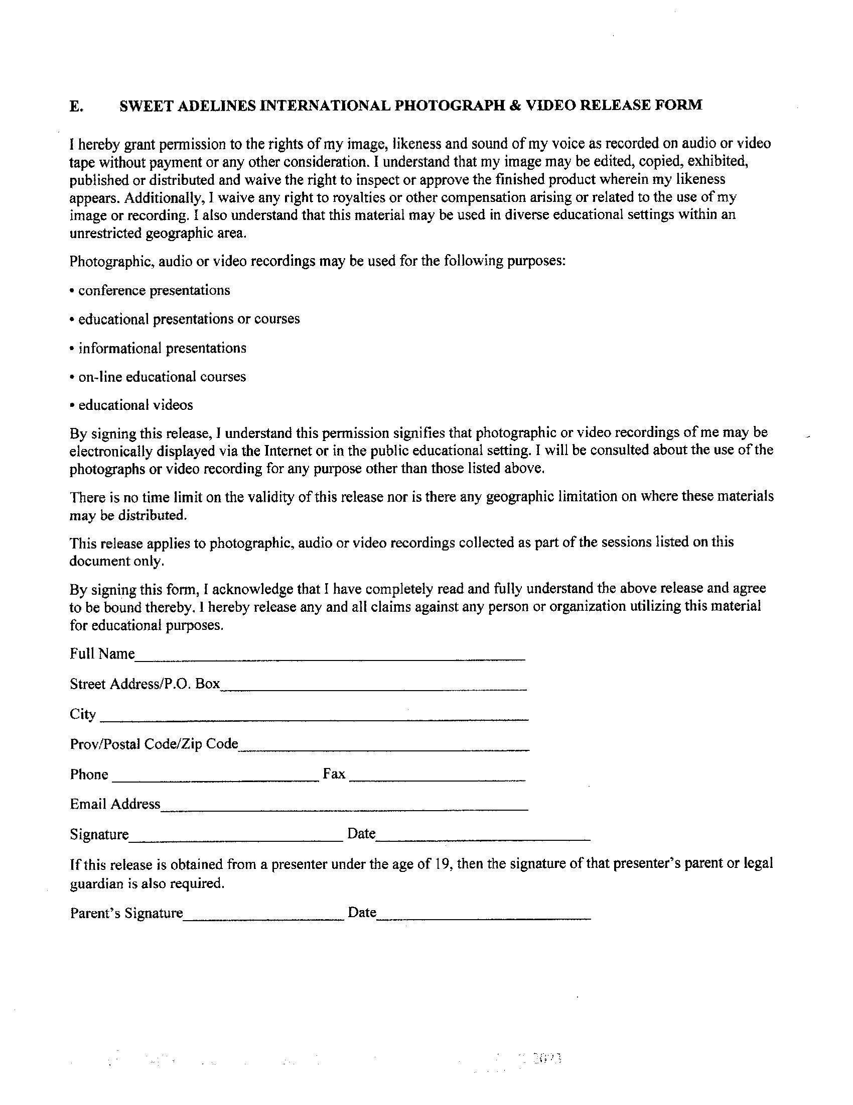

Please complete and bring **TEN (10) COPIES** to Thursday Briefing

## 2023 Regional QUARTET Open Division Cue Sheet

**You MUST turn in 10 copies of this form to your region's Competition Coordinator AT THE BRIEFING.** This form **MUST** be used. No other form will be accepted!

|  |  |
| --- | --- |
| Quartet Name: NameNameName: | Contestant #: |

**Note:** Timing begins at the first word spoken or the first chord of the first song, whichever begins the performance, and continues through the final chord of the last song or the last word spoken, whichever concludes the performance. The prepared program must list all planned activity occurring on stage after completion of the entrance and following the official introduction. Planned activity occurring prior to the first word spoken or the first chord of the first song, whichever begins the performance, will result in disqualification if in the opinion of the panel chair and a majority of judges on the panel the time spent is excessive and results in a delay of the contest.

**PLEASE USE LAYMAN'S TERMS; DON'T USE A CUE INDICATING THE NUMBER OF MEASURES INTO A SONG**

|  |  |  |  |  |  |  |
| --- | --- | --- | --- | --- | --- | --- |
| ENTRANCE is permitted from stage left ( **L** ),  center stage ( **C** ) and stage right ( **R** ).*  Indicate from which direction each member will  enter by marking the appropriate position number with a letter*, *If offered by region* |  | | | |  |  |
| 1. | 2. | 3. | 4. |
|  | | | |
| OPTIONAL LIGHTING | | | | EMCEES WORK | PLANNED ACTIVITY |
| List song titles and check **all** boxes that apply. If a medley is used, list **ALL** songs included in the medley.  Please check which song is to be judged as your contest song. | Traditional White/White is used during competition songs. White, combined with one additional color (Red, Lavender, Blue, Amber, Green, or Magenta), is for **non-contest songs only.** Indicateadditional lighting color if desired.*\*If available from region.* | | | | **Briefly** describe emcee work and  when it occurs, that is before or  after the song. | **Briefly** describe any special moves,  indicating location on stage. |
| SONG TITLE: |  | | | |  | This song is: **□**Uptune **□**Ballad |
| Contest Song? **□**Yes **□** No  **□**Yes **□** No |
| SONG TITLE: |  | | | |  | This song is: **□**Uptune **□**Ballad |
| Contest Song? **□**Yes **□** No |
| SONG TITLE: |  | | | |  | This song is: **□**Uptune **□**Ballad |
| Contest Song? **□**Yes **□** No |
| Page 1 of 2 | | | | | | |

**2023 Regional QUARTET Open Division Cue Sheet**

**You MUST turn in 10 copies of this form to your region's Competition Coordinator AT THE BRIEFING.** This form **MUST** be used. No other form will be accepted!

|  |  |
| --- | --- |
| Quartet Name: NameNameName: | Contestant #: |

PLEASE USE LAYMAN'S TERMS; DON'T USE A CUE INDICATING THE NUMBER OF MEASURES INTO A SONG

|  |  |  |  |
| --- | --- | --- | --- |
| . | **OPTIONAL LIGHTING** | **EMCEES WORK** | **PLANNED ACTIVITY** |
| List song titles and check **all** boxes that apply. If a medley is used, list **ALL** songs included in the medley.  Please check which song is to be judged as your contest song | Traditional White/White is used during competition songs. White, combined with one additional color (Red, Lavender, Blue, Amber, Green, or Magenta), is for **non-contest songs only.** Indicateadditional lighting color if desired.*\*If available from region.* | **Briefly** describe emcee work and when it occurs, that is before or after the song. | **Briefly** describe any special moves,  indicating location on stage. |
| **SONG TITLE:** |  |  | This song is: **□**Uptune **□**Ballad |
| Contest Song? **□**Yes **□** No |
| **SONG TITLE:** |  |  | This song is: **□**Uptune **□**Ballad | FINAL POSE |
| Contest Song? **□**Yes **□** No | **Briefly** describe final bow and pose at the end of the performance. |
| **SONG TITLE:** |  |  | This song is: **□**Uptune **□**Ballad` |  |
| Contest Song? **□**Yes **□** No |
| Is your package starting with spoken word? **□**Yes **□** No | | Is your package ending with spoken word? **□**Yes **□** No | | |
| Page 2 of 2 | | | | | |

# 

